# ARCHITECTURE

A[Vendor Portal] -->|Submit Data| B(Microservice)

B -->|REST/Kafka| C[Workflow Engine]

C --> D[PostgreSQL]

C --> E[Email Service]

C --> F[Approval Teams]

D --> C[State Recovery]

# DATABASE SCHEMA

-- Workflow Definitions

CREATE TABLE workflow_definitions (

id TEXT PRIMARY KEY,

name TEXT NOT NULL,

version TEXT NOT NULL,

json_config JSONB NOT NULL,

created_at TIMESTAMPTZ DEFAULT NOW(),

is_active BOOLEAN DEFAULT TRUE

);

-- Workflow Instances

CREATE TABLE workflow_instances (

instance_id TEXT PRIMARY KEY,

workflow_id TEXT REFERENCES workflow_definitions(id),

vendor_id TEXT NOT NULL,

current_status TEXT NOT NULL,

current_phase TEXT,

context_data JSONB,

created_at TIMESTAMPTZ DEFAULT NOW(),

updated_at TIMESTAMPTZ DEFAULT NOW()

);

-- Workflow Checkpoints

CREATE TABLE workflow_checkpoints (

instance_id TEXT REFERENCES workflow_instances(instance_id),

phase_id TEXT NOT NULL,

step_id TEXT NOT NULL,

status TEXT NOT NULL,

output_data JSONB,

completed_at TIMESTAMPTZ,

PRIMARY KEY (instance_id, phase_id, step_id)

);

-- Pending Tasks

CREATE TABLE pending_tasks (

task_id TEXT PRIMARY KEY,

instance_id TEXT REFERENCES workflow_instances(instance_id),

step_id TEXT NOT NULL,

callback_url TEXT NOT NULL,

status TEXT NOT NULL,

created_at TIMESTAMPTZ DEFAULT NOW(),

expires_at TIMESTAMPTZ

);

-- Failed Messages (For Recovery)

CREATE TABLE dead_letters (

id SERIAL PRIMARY KEY,

message_body JSONB NOT NULL,

source_service TEXT NOT NULL,

error TEXT,

created_at TIMESTAMPTZ DEFAULT NOW()

);

# WORK FLOW CORE MODELS

// WorkflowDefinition.cs

public class WorkflowDefinition

{

public string Id { get; set; }

public string Name { get; set; }

public string Version { get; set; }

public WorkflowConfig Config { get; set; }

}

public class WorkflowConfig

{

public List<WorkflowPhase> Phases { get; set; }

public Dictionary<string, object> Parameters { get; set; }

}

public class WorkflowPhase

{

public string PhaseId { get; set; }

public string Type { get; set; } // "sequential", "parallel"

public string Condition { get; set; }

public List<WorkflowStep> Steps { get; set; }

}

public class WorkflowStep

{

public string StepId { get; set; }

public string Action { get; set; } // "api_call", "approval", "email"

public Dictionary<string, object> Config { get; set; }

public string Condition { get; set; }

}

# WORKF FLOW SERVICE

// WorkflowService.cs

public class WorkflowService

{

private readonly IWorkflowRepository _repository;

private readonly IStepExecutor _stepExecutor;

private readonly IConditionEvaluator _conditionEvaluator;

public async Task<string> StartWorkflow(string workflowId, string vendorId, object initialData)

{

var instanceId = Guid.NewGuid().ToString();

await _repository.CreateInstance(instanceId, workflowId, vendorId, initialData);

await ProcessNextSteps(instanceId);

return instanceId;

}

public async Task ProcessNextSteps(string instanceId)

{

var instance = await _repository.GetInstance(instanceId);

var definition = await _repository.GetDefinition(instance.WorkflowId);

foreach (var phase in definition.Config.Phases)

{

if (!_conditionEvaluator.Evaluate(phase.Condition, instance.ContextData))

continue;

if (phase.Type == "sequential")

await ProcessSequentialPhase(instance, phase);

else

await ProcessParallelPhase(instance, phase);

}

}

private async Task ProcessSequentialPhase(WorkflowInstance instance, WorkflowPhase phase)

{

foreach (var step in phase.Steps)

{

if (!_conditionEvaluator.Evaluate(step.Condition, instance.ContextData))

continue;

var result = await _stepExecutor.Execute(step, instance);

await _repository.SaveCheckpoint(

instance.InstanceId,

phase.PhaseId,

step.StepId,

result.Status,

result.Output);

if (!result.Success && step.Config["onFailure"] == "restartPhase")

break; // Will restart phase on next recovery

}

}

}

# STEPS EXECUTOR

// EmailStepExecutor.cs

public class EmailStepExecutor : IStepExecutor

{

public string ActionType => "email";

public async Task<StepResult> Execute(WorkflowStep step, WorkflowInstance instance)

{

var emailServiceUrl = step.Config["serviceUrl"].ToString();

var payload = new {

To = step.Config["recipient"],

Template = step.Config["template"],

Context = instance.ContextData

};

using var client = new HttpClient();

var response = await client.PostAsJsonAsync(emailServiceUrl, payload);

return new StepResult(

response.IsSuccessStatusCode,

await response.Content.ReadAsAsync<Dictionary<string, object>>());

}

}

// ApprovalStepExecutor.cs

public class ApprovalStepExecutor : IStepExecutor

{

public string ActionType => "approval";

public async Task<StepResult> Execute(WorkflowStep step, WorkflowInstance instance)

{

var taskId = Guid.NewGuid().ToString();

await _repository.CreatePendingTask(

taskId,

instance.InstanceId,

step.StepId,

$"{_config.CallbackBaseUrl}/approvals/{taskId}",

"pending");

return StepResult.Pending(); // Engine will wait for callback

}

}

# COMMUNICATION (OPTION A – REST API)

// WorkflowController.cs

[ApiController]

[Route("api/workflows")]

public class WorkflowController : ControllerBase

{

[HttpPost("start")]

public async Task<IActionResult> StartWorkflow(

[FromBody] StartWorkflowRequest request)

{

var instanceId = await _workflowService.StartWorkflow(

request.WorkflowId,

request.VendorId,

request.InitialData);

return Ok(new { InstanceId = instanceId });

}

[HttpPost("callbacks/{taskId}")]

public async Task<IActionResult> HandleCallback(

string taskId,

[FromBody] CallbackData data)

{

await _workflowService.ProcessCallback(taskId, data);

return Ok();

}

}

# ENGINE RECOVERY SYSTEM

// WorkflowRecoveryService.cs

public class WorkflowRecoveryService : BackgroundService

{

protected override async Task ExecuteAsync(CancellationToken stoppingToken)

{

while (!stoppingToken.IsCancellationRequested)

{

var incompleteInstances = await _repository.GetIncompleteInstances();

foreach (var instance in incompleteInstances)

{

await _workflowService.ProcessNextSteps(instance.InstanceId);

}

await Task.Delay(TimeSpan.FromMinutes(5), stoppingToken);

}

}

}

# RECOVERY (INSIDE THE MICROSERVICE)

// In your microservice:

public async Task SubmitToWorkflowEngine(object data)

{

try

{

// Try REST first

var response = await _httpClient.PostAsJsonAsync(

"http://wfe/api/workflows/start",

data);

if (!response.IsSuccessStatusCode)

throw new Exception("Workflow engine unavailable");

}

catch (Exception ex)

{

// Fallback to database

await _db.ExecuteAsync(

@"INSERT INTO dead_letters

(message_body, source_service, error)

VALUES (@Body, 'vendor-service', @Error)",

new { Body = JsonSerializer.Serialize(data), Error = ex.Message });

}

}

# WORK FLOW JSON (SAMPLE)

{

"id": "vendor-prequalification-v1",

"name": "Vendor Prequalification",

"phases": [

{

"phaseId": "initial-review",

"type": "sequential",

"condition": "true",

"steps": [

{

"stepId": "send-acknowledgement",

"action": "email",

"config": {

"serviceUrl": "http://email-service/send",

"template": "vendor-submission-ack",

"recipient": "{{vendor.email}}"

}

},

{

"stepId": "finance-approval",

"action": "approval",

"condition": "{{vendor.contractValue}} > 50000",

"config": {

"approvers": ["finance-team@company.com"],

"onFailure": "restartPhase"

}

}

]

},

{

"phaseId": "hse-review",

"type": "parallel",

"condition": "{{vendor.industry}} == 'construction'",

"steps": [

{

"stepId": "safety-check",

"action": "api_call",

"config": {

"url": "http://hse-service/validate",

"method": "POST",

"successCondition": "response.status == 'approved'"

}

}

]

}

]

}

# EXAMPLE

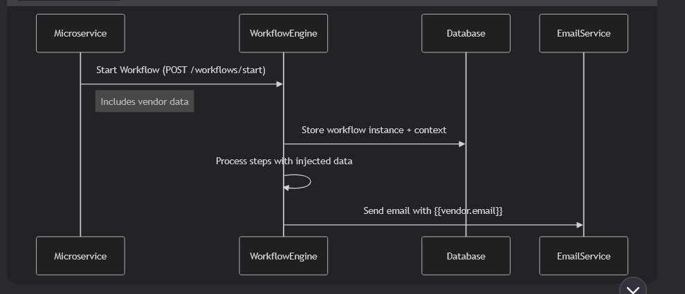

Microservice initiating the work flow.

// In your Vendor Submission Microservice

public async Task SubmitVendor(VendorSubmissionRequest request)

{

// 1. Save vendor data to your database

var vendorId = await _vendorRepository.SaveVendor(request);

// 2. Prepare workflow initial data

var workflowData = new {

vendor = new {

id = vendorId,

email = request.ContactEmail,

contractValue = request.EstimatedContractValue,

industry = request.BusinessCategory

},

documents = request.DocumentUrls

};

// 3. Start workflow (REST API call)

var response = await _httpClient.PostAsJsonAsync(

"http://workflow-engine/api/workflows/start",

new {

WorkflowId = "vendor-prequalification-v1",

VendorId = vendorId,

InitialData = workflowData // <-- Critical payload

});

response.EnsureSuccessStatusCode();

}

Based on the initial values, prepare a json like this,

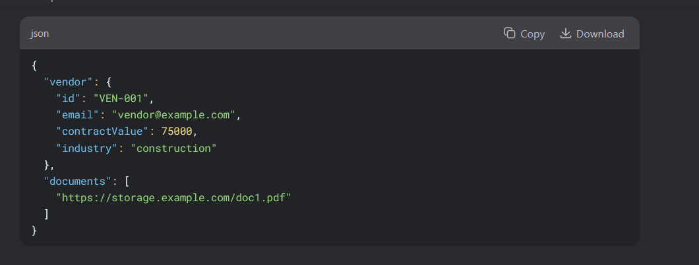

Save this information in the workflow engine as the initial data for the workflow instance. Take this Json and compare with the workflow instance json config and fill the required information as below.

public class TemplateEngine

{

public string Render(string template, object contextData)

{

return Regex.Replace(template, @"\{\{(.+?)\}\}", match =>

{

var path = match.Groups[1].Value;

return (string)JsonPathQuery(contextData, path);

});

}

private object JsonPathQuery(object data, string path)

{

// Simplified JSON path resolver

var parts = path.Split('.');

object current = data;

foreach (var part in parts)

{

if (current == null) return null;

var prop = current.GetType().GetProperty(part);

current = prop?.GetValue(current);

}

return current;

}

}

Email engine can use the data like the below.

public class EmailStepExecutor : IStepExecutor

{

public async Task<StepResult> Execute(WorkflowStep step, WorkflowInstance instance)

{

// Resolve templates

var resolvedRecipient = _templateEngine.Render(

step.Config["recipient"].ToString(),

instance.ContextData);

var payload = new {

To = resolvedRecipient, // Now "vendor@example.com"

Template = step.Config["template"],

Context = instance.ContextData

};

// Send to email service

var response = await _httpClient.PostAsJsonAsync(

step.Config["serviceUrl"].ToString(),

payload);

return new StepResult(response.IsSuccessStatusCode);

}

}

DATA FLOW:

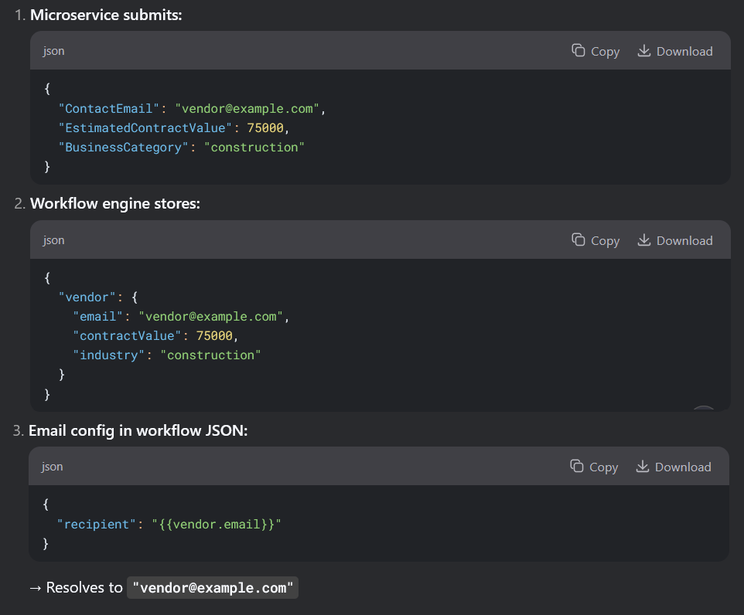

# DECOUPLED DATA FLOW STRATEGY

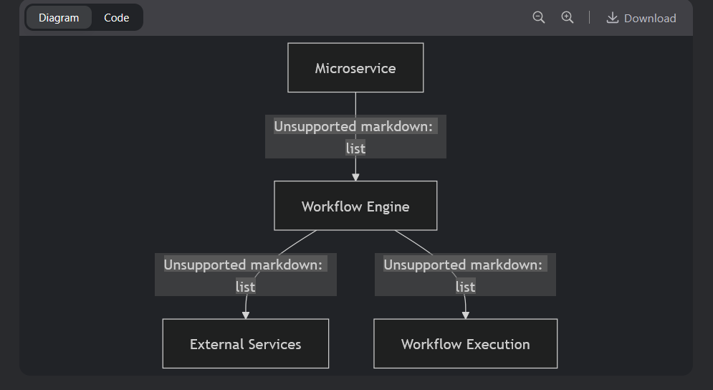

Stragey

Microservice passes in only the minimal data required for initiating the workflow.

// Microservice initiates workflow with JUST the vendor ID

await _workflowClient.StartWorkflow("vendor-prequal", new {

VendorId = vendor.Id // Only the essential ID

});

Workflow engine fetch additional data when needed.

{

"steps": [

{

"stepId": "enrich-vendor-data",

"action": "api_call",

"config": {

"url": "http://vendor-service/vendors/{{vendorId}}",

"resultPath": "vendor" // Stores response here

}

},

{

"stepId": "send-email",

"action": "email",

"config": {

"recipient": "{{vendor.contactEmail}}", // Uses enriched data

"template": "welcome"

}

}

]

}

Allow for fall back values in the config definition.

{

"parameters": {

"approvalDeadlineDays": 7,

"requiredDocs": ["tax-id", "insurance-certificate"]

},

"steps": [

{

"config": {

"deadline": "{{parameters.approvalDeadlineDays}} days"

}

}

]

}

Enrichment concept:

